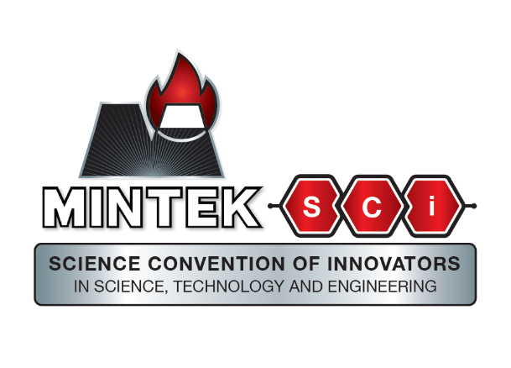
Mintek Grad Hackathon AI for Mineral Processing Optimisation

Problem Statement
Flotation circuits in mineral processing are essential for separating valuable minerals from ore. However, these circuits often suffer from variability due to the complex and changing nature of ore characteristics and processing conditions. This leads to inconsistent recovery rates, where valuable minerals are lost or less efficiently recovered. Such inefficiencies not only reduce mineral output and profitability but also increase energy consumption and operational costs, undermining sustainability and competitiveness.

Challenge
Develop an AI or machine learning algorithm that:
- Analyses real-time or historical data from flotation circuits.
- Predicts and reduces variability in recovery rates.
- Improves operational efficiency and sustainability of mineral processing.

Deliverable
A functional AI model or predictive algorithm demonstrating improved mineral recovery performance. Submissions should include a comparative performance analysis against baseline recovery rates and a demonstration of how the model can be implemented in an operational environment.

